3 PYTHON NOTES
1/print("My name is Shahria Husen .My age is 19 years.")
print("My name is Shahria husen.")
print("My age is 19 years.")
print(44)
print(45)
print(34*45)

2/name=("Sahahris Husen")
age=23
price=25.99
print(price)
print parentheses quotation remove korthe hobe onnothai
output price asbe value asbe na
print(type(name))= output ar type asbe
str=string(name/para/sentence)
2/Python case sensitive language
3 a=1.5,b=3
C=a//b
=o.5 ay ketre kaser suto integer hobe main outcome
So c=0
4 n/d lob/hor (n=+,d=-)=-neg
5 n/d (n=-,d=+)=+pos
6 logical operator in paython( and,nor ,or)
7 a**b a to power b
MAIN SYNTEX
If (condition):
Statement1{print()}
Print()
Elif condition):
Statement2
Else:
StatementN
1 single line operator is called ternary operator
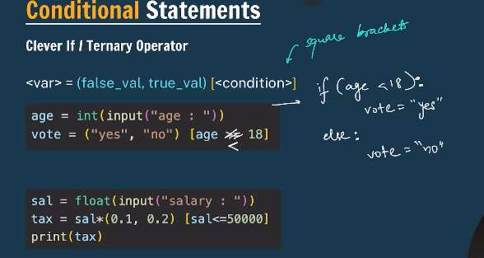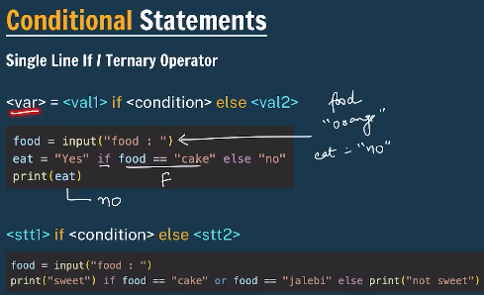

Num=10
Num=num+10
Num+=10

3 a=”2”
B=4.25
Print(type(a))
Print(a+b)
4 in python for line break \n\
5 slicing (negative index)
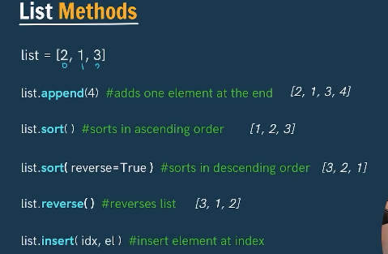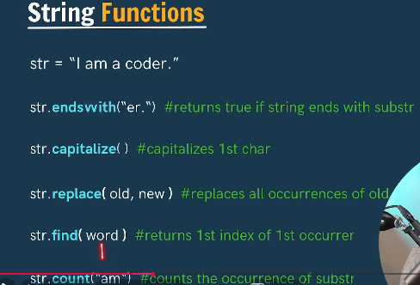

1 tuple /dictionary /nested dictionary
2 in break if there is lists of number if you write break that
Means you can not print further .
I=1/ while (i<=5): / if(i==3)/ break
Output(1,2,3)
3 if you write continue that mean except this
I=1/ while (i<=5): / if(i==3)/ continue
Output(1,2,4,5)
4 for i in range (1,100):
Print(i)
5 factorial 5=1*2*3*4*5
7=1*2*3*4*5*6*7
2=1*2

6 work on factorial
7 function and definition
def calc_sum(a,b):
sum=a+b
print(sum)
return sum
calc_sum(5,7)
calc_sum(15,12)
calc_sum(20,25)
output 12/27/45
8

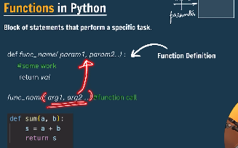
1 // is called integer division or floor division.
(10//3)=3.33 main ans 3(nearest interger smaller one)
2 for range function
i=6
for i in range(1,6):
print(i)
3 range(start, stop, step)
4 for i in range(10,1,-1):
print(i,end="")

5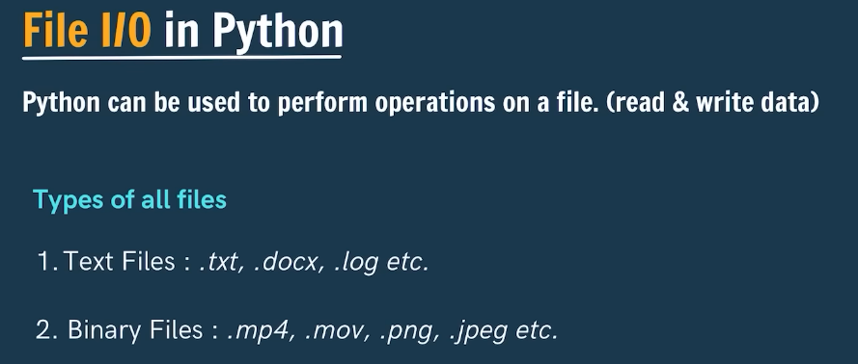
6
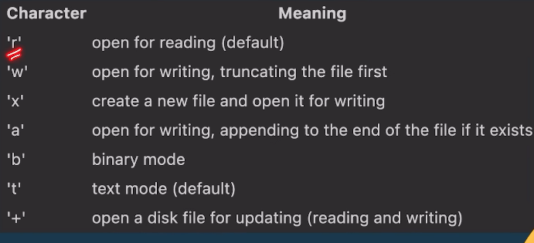

7 Mutable means:
👉 You can change the value of an object after it is created, without creating a new object.
7 immutable you cant change.
8 print("Ther is no on in this world \"greatest\", \nand cool guy ")
9 Ther is no on in this world "greatest",
and cool guy

1 list=[4,5,6, ["apple","banana"],["True","False"],10]
print(list)
2 list contents square []
3 tuple contents parenthesis ()
4 dictionary contents curle vasis {}
list=[4,5,5,[True,False],["@","$","%"],00]
tuple=("no one",("bad guy","good guy"),(1,2,3,5))
dict={"mother","father",1,2,3,50,True,False }
print(list)
print(tuple)
print(dict)
5 list=["shahria", "shakib","shahria"]
print(list)
print(type(list))
print(set(list))
by using set function output will come unique I mean input never repeat
10
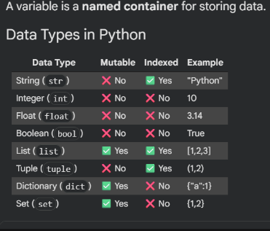

10 # name="SHAHRIA HUSEN"
# # name="Harry"
# # print(name[-5:-1]) ANS HUSE
# # print(name[-4:0])
# # name="Husen"
# # print(name[0:4]) SHAH

# name="Shahria Husen"
# print(name.upper())
# name1="shahria husen"
# print(name1.lower())
# name2="shakib husen"
# print(name2.upper())
# print(name2.lower())
# name3="harry"
# print(name3.upper())
# print(name3.lower)
# print(len(name3))

strip() :
The strip() method removes any white spaces before and after the string.

Example:
str2 = " Silver Spoon "
print(str2.strip)

Output:
Silver Spoon

rstrip() :
the rstrip() removes any trailing characters. Example:
str3 = "Hello !!!"
print(str3.rstrip("!"))

Output:
Hello

The capitalize() method turns only the first character of the string to uppercase and the rest other characters of the string are turned to lowercase. The string has no effect if the first character is already uppercase

center() :
The center() method aligns the string to the center as per the parameters given by the user.

Example:
str1 = "Welcome to the Console!!!"
print(str1.center(50))

Output:
Welcome to the Console!!!
1 name="SHAHRIA HUSEN"
for i in name:
print(i, end=" ")
print(i)
S, H,A,H,R,I,A H,U,S,E,N
S
H
A
H
..
1 for loop
For I in range ( start,end,step)
For I in range(0,101,10)
For I in range(1,2001)
Print(i)
Out hobe 1 to 2000
5
emails=["user1@gmail.com","user2@gmail.com","admin@gmail.com"]

for email in emails:
print(f"Sending the notification to {email}")

10 if you don’t mention the value of I first /it automatically increased by 1 as it ahead
11
old_new=["xyz@gmail.com","abc@gmail.com","xxx@gmail.com"]
new_email=["xyz@gmail.com","not@gmail.com"]
print(set(old_new+new_email))
set help you to find out the unique emails

1

